ANSWER KEY
WINTER STUDENT ENRICHMENT PACKET
Grade 3
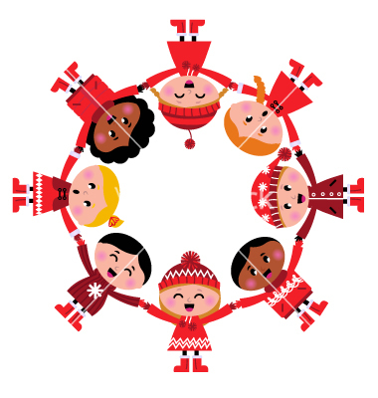
Elementary Reading/English Language Arts and Social Studies

™
Prince George’s County Public Schools
Office of Academic Programs
Department of Curriculum and Instruction
Table of Contents
DIRECTIONS 3
Vocabulary Activities 4
Word Work/Phonics Activities 5
A Country for Everyone 6
Snowstorms in Action 8
The Mystery of the Missing Apples 11
Writing Prompt 15
Reading Log 17

THIRD GRADE WINTER STUDENT ENRICHMENT PACKET
Note to Students:
You’ve learned a great deal already this school year! It is important that you keep your brain active over the Winter Break. In this packet, you will find a calendar of activities to last until you return to school. When you’re not sledding, or drinking hot chocolate, complete this packet so you will get off to a good start in the New Year!

DIRECTIONS

Complete each activity in the Winter Student Enrichment Packet. Write your responses in the spaces provided.

Parents are encouraged to assist in the following ways:

- Make a plan to complete the activities during the Winter Break.

- Provide a quiet space and time for your child to work on the packet.

- Help your child with the directions and completing the activities.

- Review and discuss your child’s responses. Provide positive feedback and praise for sincere effort and independence.

- Encourage daily reading of 20 -30 minutes of a self-selected book. Read to your child, listen to him/her read, or share the reading.

- Encourage fact practice and assist as needed.

Thank you for helping your child to succeed!

Vocabulary Activities

Directions: As you read each sentence, use the other words in the sentence to help you figure out what the underlined word means. Then circle the answer you have chosen.

- I felt elated when I won the geography bee.

Elated means __________.

- joyful
- nervous
- terrible
- tired

- Joe was anxious about taking the social studies test because he had not studied at all.

Anxious means __________.

- calm
- happy
- nervous
- excited

- Susan was cautious when she walked through the museum because there was a wet paint sign.

Cautious means __________.

- careless
- happy
- frightened
- careful
Directions: Read each sentence. Then choose the answer in which the underlined word is used in the same way. Circle the answer you have chosen.

- Our class is putting on a play about Martin Luther King Jr.

In which sentence does the word play mean the same thing as in the sentence above?

- I love to play outside when it is hot.
- Jim got a great part in this year’s play.
- Jason knows how to play the trumpet.
- The boys were buying play trucks.

- I have a brush for my dog that I use after I give him a bath.

In which sentence does the word brush mean the same thing as in the sentence above?

- The field is covered with scratchy brush.
- I need to brush the dirt off my pants since I fell.
- You can clean your brush with soap and water.
- I was scratched when I had a brush with a wild cat.

Word Work/Phonics Activities

Directions: Read each question and choose the best answer. Circle your answer.

- In which word does un mean not?

- funny
- unusual
- universe

- The re in rewrite means the same as the re in:

- ready
- reason
- reuse

- The er in teacher means the same as the er in:

- weather
- worker
- greater

Directions: Read each question. Look at the underlined letter or letters and the underlined word in the question. The underlined letter or letters stand for a sound in the underlined word. Decide which of the other three words has the same sound in it. Then circle the answer you have chosen.

- In which word does the letter g have the same sound as it does in the word manager?

- going
- giraffe
- greatness

- In which word does the letter e have the same sound as it does in the word before?

- ready
- better
- rewind

- In which word does the letter a have the same sound as it does in the word later?

- lady
- apple
- snack

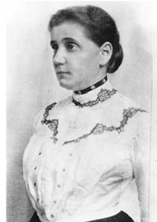
Jane Addams
Founder of Hull House
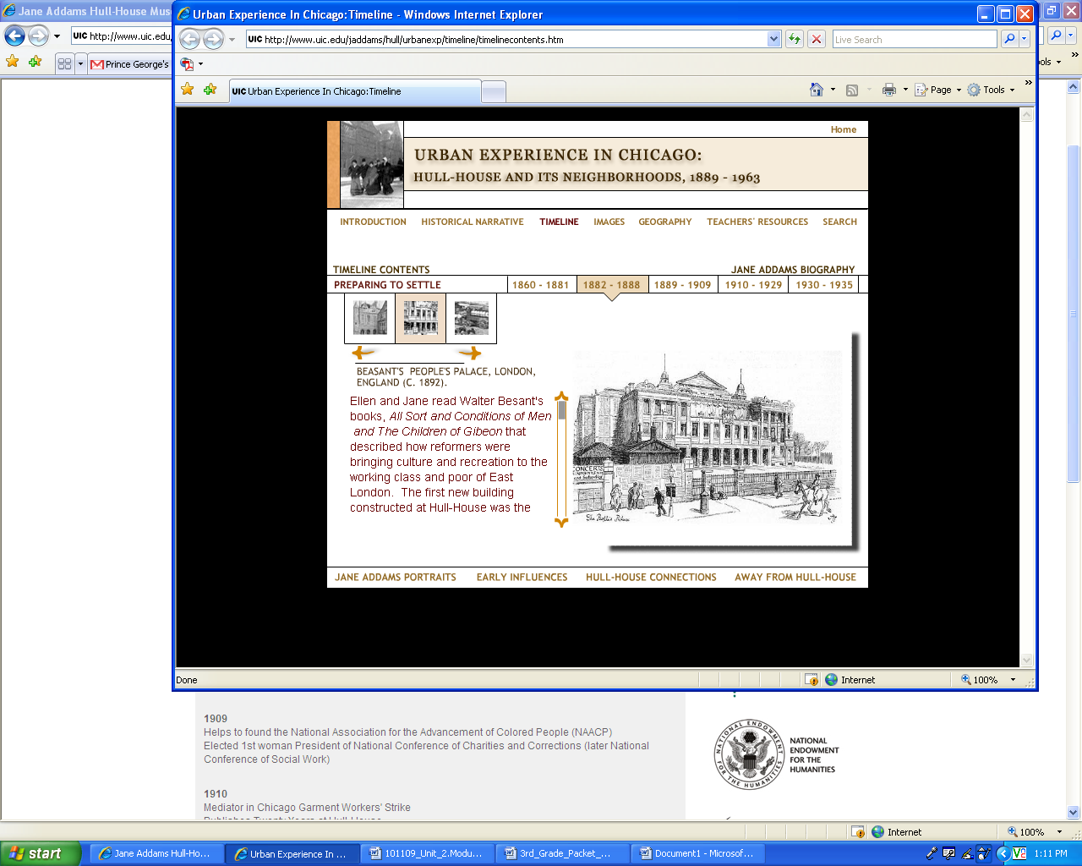

A Country for Everyone

A Country for Everyone
2005, pp. 82-83
Copyright © 2005 Scott Foresman. All rights reserved. Reprinted with permission

In the late 1800’s, people came to our country from all over the world to live in freedom. Jane Addams wanted to help these immigrants get used to their new home.

Jane Addams’s father taught her to treat everyone fairly. She knew that there were new immigrants to the United States who needed a fair chance to succeed. She opened a special place where immigrants in a neighborhood could get help so they could build new lives.

Immigrant- a person that moves into a country and lives there

City- a town with a large population

Neighborhood- a place where people live
Communities- a place where people live, work, and have fun together

Nobel Peace Prize- an award given to a person who works for world peace

Jane Addams started Hull House in Chicago, Illinois, in 1889. Hull House quickly became an important part of the community. It had a health clinic, a child-care center, a kindergarten, and a playground. It had classes where people could learn English, art, music, and crafts. People who worked in Hull House also worked to get cleaner streets and better housing in the city.

Because of Jane Addams, many immigrants adjusted more easily to their new communities. Because of her work, Addams was given the Nobel Peace Prize in 1931. She was the first American woman to win this prize. The prize is given every year to a person who has worked hard to help world peace.

Directions: After you read “A Country for Everyone,” answer the questions below.

    - What is the author’s opinion about Jane Addams’ work with Hull House?

- Immigrants were given a fair chance to succeed.
- Immigrants adjusted more easily to the community.
- Immigrants needed help to build new lives.
- Immigrants needed to get used to living in America.

    - What is the main idea of the reading selection?

- Jane Addams’ actions helped many people.
- Many immigrants adjusted more easily because of Jane Addams.
- Jane Addams was the first American to win the Nobel Peace Prize.
- Many people tried to improve their community.

    - Where would this passage most likely be found?

- in a dictionary
- in a news article
- in a poetry book
- in a children’s picture book
What words or details support your response above? Write them in the space below.

________Answers may vary._______________________________________________________
______________________________________________________________________________

    - Find out about a program in your community that helps people now.
Answers to the response below may vary.
Name of Community Organization: ________________________________________________

What do they do? _______________________________________________________________

How do they show that people think everyone should be treated fairly?__________________

______________________________________________________________________________

______________________________________________________________________________

______________________________________________________________________________

Snowstorms in Action

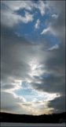
Storm Clouds Above Maryland
High storm clouds float above Maryland. This storm will bring more than 6 inches (15 centimeters) of snow. (Credit: (c) AP Images)
By Jim Mezzanotte

A snowstorm begins with clouds. They form when air rises from the ground. The air is warmer than air higher up.

The warm air is full of water. The water is not a liquid. It is a gas called water vapor. We cannot see water vapor.

The air cools as it rises higher in the sky. The water vapor turns back into a liquid. It becomes water drops.

If the air is very cold, the water drops freeze. They become tiny pieces of ice. These tiny pieces are called ice crystals.

The ice crystals form clouds. The crystals join together, becoming snowflakes. The snowflakes fall from the clouds.
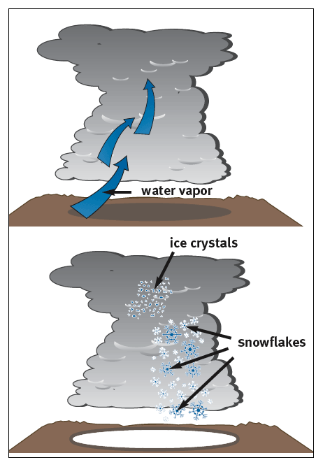
Diagram: Snowflakes Forming in a Cloud
Rising water vapor condenses into water drops. The drops freeze and form ice crystals. Several crystals make up each snowflake.
(Credit: Scott M. Krall/(c) Weekly Reader Early Learning Library)

You might not see these snowflakes. Closer to the ground, the air may be too warm. The snow melts as it falls and becomes rain.

For snow to fall, the air must be cold. It must be near the freezing temperature of 32°Fahrenheit (0°Celsius).

Ice crystals join together in different ways. They make all kinds of snowflakes. No two snowflakes are the same. Each one is different.
Some snowflakes are big and fluffy. They look like stars. Others are small and hard. They look like tiny needles. All snowflakes have six sides.
When a blizzard hits, strong winds blow. They make a bad storm even worse! With no wind, snow falls straight down. But strong winds blow snow sideways. They blow snow already on the ground, too.
When winds blow, snow does not pile up evenly. In some places, the snow hardly covers the ground. In other places, the wind blows the snow into high piles called snowdrifts.
12
Sometimes, sleet or freezing rain falls instead of snow. The snow falls into warmer air and melts. It then falls through cold air. It freezes again, becoming sleet.
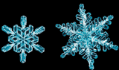
Snowflakes
The ice crystals in snowflakes look like pieces of glass.
(Credit: (c) Richard Walters/Visuals Unlimited)
Snowflakes do not always freeze again. Sometimes, they fall as very cold raindrops. When this rain hits the cold ground, it freezes. It covers everything with ice.
13

WR STORMS: SNOWSTORMS
2007, pp. 10-15

Copyright © 2007 by Weekly Reader® Early Learning Library. All rights reserved. Reprinted with permission.

Directions: After you read “Snowstorms in Action,” answer the questions below.

- How is paragraph 12 organized?

- by giving the main idea and details
- by explaining differences between two things
- by telling a problem and a solution
- by putting events in order

- The purpose of this article is to________________________________________.

- explain how dangerous snowstorms can be for people
- give information about snowstorms and how they are formed
- persuade people to take snowstorms seriously
- describe the effects of snowstorms on areas

- Read the sentence from paragraph 13 of the passage.

When this rain hits the cold ground, it freezes.

In which sentence does the word hits mean the same thing as in the sentence above?

- The songs were big hits with teenagers.
- I get excited when the answer hits me.
- The trumpet player always hits the right note.
- The ball bounces after it hits the floor.

- After reading this article, a reader might still want to know

- how snow piles up when the wind blows
- how cold it must be for snow to fall
- how strong the winds are during a blizzard
- how ice crystals form in the air

- Explain how you know “Snowstorms in Action” is nonfiction. In your response, use information from the article that supports your explanation. Write your answer in the space below.
Sample only…answers may vary.

I know “Snowstorms in Action” is nonfiction and not a story because there are no characters or

problems. It is nonfiction because it is giving you facts. It is nonfiction because it is about how

snowstorms start and how cold it needs to be in order for snow to fall. This nonfiction article

has a diagram that gives you information. It shows how snowstorms start with water vapor

rising into the cool air and then falling as ice crystals. It also includes pictures and captions from

the Weekly Reader.

The Mystery of the Missing Apples

By Clare Mishica

Rabbit Looking for Apples
(Art by Richard Johnson)

"Yes!" cheered Rabbit as he peeked out his window. "The rain has stopped. Now I can pick the big red apples on my tree and make a pie.” He grabbed a basket and climbed the little hill behind his house. But when he got to the top, he saw that the apples on his tree were gone.

"Oh no!" cried Rabbit.

"What's wrong?" asked Raccoon, who was passing by.

“Someone took my apples," said Rabbit.

"Don't worry," said Raccoon. "I've read lots of mystery books. I can solve this mystery. First, we have to look for clues. Are there any footprints?"

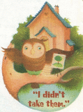
Owl Talking to Rabbit and Raccoon
(Art by Richard Johnson)
Rabbit looked down at his muddy feet. "Only mine," he said.

Raccoon twisted his tail in a knot while he thought about that clue. "I've got it!" he finally shouted. "That means whoever took the apples didn't step on the ground. Maybe it was Owl. He could have flown away with them."

“Maybe,” said Rabbit. "We could go ask him."

So Rabbit and Raccoon visited Owl.

"Those apples looked juicy, but I didn't take them," said Owl. "Look, my feathers are dry. I've been inside all day painting this picture. Maybe you should talk to Bat. She's hanging her clothes to dry, and her fur is all wet."
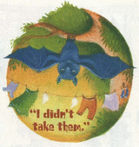
Bat Talking to Rabbit and Raccoon
(Art by Richard Johnson)

"Yes!" agreed Raccoon. "Bat can fly, and she has wet clothes and wet fur. The clues point to Bat."

So Rabbit and Raccoon visited Bat. But she didn't have the apples, either.
12
"Your apples looked juicy, but I didn't take them," said Bat. She was hanging a towel on her clothesline. "I was making spaghetti this afternoon when a crash of thunder frightened me. I dropped my pot, and the spaghetti spilled all over. I had to take a bath and wash my clothes!"

"Now what?" Rabbit asked Raccoon.

Raccoon didn't answer. He was watching Bat's green towel flap in the breeze.
"That towel is the best clue of all!" Raccoon shouted at last. "It points to the real bandit."
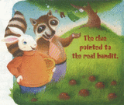
Rabbit and Raccoon Looking at the Apples
(Art by Richard Johnson)

"Who is that?" asked Rabbit. He didn't think the towel pointed at anyone. Maybe Raccoon needed more practice at figuring out mysteries.

"Come see," said Raccoon. He hurried back to Rabbit's house.

Rabbit followed Raccoon up the little hill behind his house. He followed him around the apple tree and down the hill again. Suddenly, Raccoon stopped. He bent down and picked up two juicy apples. They were hiding in the grass.

"Bat's towel reminded me how windy it was during the rainstorm," explained Raccoon. "The wind was your thief! It knocked the apples off the tree, and then they rolled down the hill."

"You're right!" cheered Rabbit. "Help me fill my basket, and we'll go make a big apple pie."

“That was a tricky mystery," Raccoon said later as they were eating the pie. "The wind didn't leave any footprints."

Rabbit laughed. "I'm just glad it didn't eat my apples!"

Highlights for Children
(Vol. 64, No. 11)
Nov 2009, pp. 6-7
Copyright © Highlights for Children. Nov 2009. All rights reserved. Reprinted with permission.

Directions: Answer the questions below after you read “The Mystery of the Missing Apples.”

- Read this sentence from paragraph 8 of the story.

I was making spaghetti this afternoon when a crash of thunder frightened me.

Crash means __________.

- collision
- loud sound
- flash
- quiet sound
- An important message in this story is that__________________________________________.
- friends should never be trusted
- determination pays off
- solving mysteries is fun
- mysteries are easy to solve
- What is Rabbit’s main problem in the story?
- Rabbit does not know how to solve mysteries.
- Rabbit is unsure about what steps to take.
- Rabbit’s apples are missing so he can’t make a pie.
- Rabbit cannot trust his friends not to take his things.

Find a sentence in the passage with details that support your response above. Write it in the space below. Answers may vary.
_______________________________________________________________________________
______________________________________________________________________________
________________________________________________________________
________________________________________________________________

- Another good title for this story is

  - “Owl Doesn’t Have the Apples”
  - “Raccoon Solves a Mystery”
  - “Rabbit’s Frustration”
  - “Working Together Helps Everyone”

- Explain how Raccoon probably feels at the end of the story. In your response, use details and examples from the story that support your explanations. Write your answer in the box below.
Sample only…answers may vary.

Raccoon probably felt proud at the end of the story because he really did help Rabbit

solve the mystery. At the beginning, Raccoon said he could help

solve the mystery because he read a lot of mystery books. He knew how to search for

clues to solve the mystery. He helped Rabbit search for clues and in the end, the

mystery was solved. It was tricky because the wind blew the apples from the tree

instead of someone taking them. That’s why he felt proud. It was a tricky mystery to

solve. ____ ________________________________________________________________

Writing Prompt

Directions: In the story “The Mystery of the Missing Apples,” Raccoon helped Rabbit discover what happened to his apples.
Based on the information in the story, write a short story about a time when one of Raccoon’s friends came to him for help. Be sure to use what you learned about his skills as a detective as you explain how Raccoon helps his friend.
To create a well-written short story:
- Write a beginning that introduces a third grade narrator or character and tells about a visit to the Museum.
- Use transition words to tell what happened in order (first, next, last…).
- Use details to help readers picture what happened.
- Write an ending for your story.
- Include proper grammar, punctuation, and spelling.

Answers will vary. Use the Grade 3 Condensed PARCC Prose Constructed Rubric to score.

______________________________________________________________________________

______________________________________________________________________________

______________________________________________________________________________

______________________________________________________________________________

______________________________________________________________________________

______________________________________________________________________________

______________________________________________________________________________

______________________________________________________________________________

______________________________________________________________________________

______________________________________________________________________________

______________________________________________________________________________

______________________________________________________________________________

______________________________________________________________________________

______________________________________________________________________________

______________________________________________________________________________

______________________________________________________________________________

______________________________________________________________________________

______________________________________________________________________________

______________________________________________________________________________

______________________________________________________________________________

______________________________________________________________________________

______________________________________________________________________________

______________________________________________________________________________

______________________________________________________________________________

______________________________________________________________________________

______________________________________________________________________________

______________________________________________________________________________

______________________________________________________________________________

______________________________________________________________________________

______________________________________________________________________________

_____________________________________________________________________________

_____________________________________________________________________________

_____________________________________________________________________________

_____________________________________________________________________________

_____________________________________________________________________________

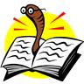
Reading Log for Winter Break: Grade 3

Read for a minimum of 15 minutes each day of Winter Break.

Date | Title | Author | Pages Read | Minutes Read

