WINTER STUDENT ENRICHMENT PACKET
Kindergarten

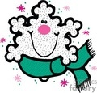

Elementary Reading/English Language Arts and Social Studies

™

Prince George’s County Public Schools
Office of Academic Programs
Department of Curriculum and Instruction
Kindergarten Winter Student Enrichment Packet
Note to Students:
You’ve learned a great deal already this school year! It is important that you keep your brain active over the Winter Break. In this packet, you will find activities to last until you return to school. When you’re not sledding, or drinking hot chocolate, complete this packet so you will get off to a good start in the New Year!

DIRECTIONS
There are six different activities in this booklet: Poetry, Newspaper, Name that Sound, Let Us Write that Way, Climate, and Television. Choose three (3) different activities to complete in this booklet.

Parents are encouraged to assist in the following ways:

- Provide your child with the necessary supplies such as a pencil, crayons, scissors, glue, etc.

- Make a plan to complete the activities during the Winter Break.

- Provide a quiet space and time for your child to work on the packet.

- Help your child with the directions. Your child should be able to do most of the activities with minimal supervision.

- Review and discuss your child’s responses. Provide positive feedback and praise for sincere effort and independence.

- If your child is just beginning to learn to write independently, encourage him/her to write and spell as best as he or she can. You may rewrite the sentence underneath the child’s to show correct letter formation and spelling.

- Encourage daily reading of 20-30 minutes of a self-selected book. Read to your child, listen to him/her read, or share the reading. Record the books read on the independent reading log attached at the end of the packet.

Thank you for helping your child succeed!
POETRY ACTIVITIES

Directions: Use the poem for the following activities.

Answers will vary.

- Read the poem aloud. Have the whole family learn it with you. Recite it as often as you can. Read and/or recite the poem to someone else in your family.

- Illustrate the poem (use the sheet provided). Be sure to include details in the poem.

- Highlight or circle the letters you find in the poem that are in your name.

- Highlight or circle the words you know in the poem. Using the words you highlighted or circled, write a sentence for each of them (use the sheet provided).

Snowman

I made him big and round,
I made him from a snowball,
I rolled upon the ground.
He has two eyes, a nose, a mouth,
A lovely scarf of red
He even has some buttons,
And a hat upon his head,
Melt, melt, melt, melt
Melt, melt, melt, melt.

From: Sing a Song of Poetry By: Gay Su Pinnell and Irene C. Fountas

Poetry Activities: Snowman

Answers below are samples only. Student answers may vary.

Words I Know From the Poem | I Can Write Sentences Too!
- I | I like the snow.
- eyes | I have two eyes.
- red | Red is my favorite color.
- big | The ball is big.
- has | He has a car.

My illustration of the poem
Answers may vary.

NEWSPAPER ACTIVITY

Directions: On the sheet provided, write the letters of your first and/or last name in the first column. Next to each letter, write or cut at least two words you can find in the newspaper that starts with that letter. Be sure that you can read the words you write down.
Answers may vary.
Letters of Your Name

 | 1. | 2.
 | 1. | 2.
 | 1. | 2.
 | 1. | 2.
 | 1. | 2.
 | 1. | 2.
 | 1. | 2.
 | 1. | 2.
 | 1. | 2.
 | 1. | 2.
 | 1. | 2.
 | 1. | 2.
 | 1. | 2.
 | 1. | 2.
 | 1. | 2.

NAME THAT SOUND ACTIVITY

Directions: Write the letter that corresponds to the beginning sound for each picture on the lines below. Challenge: Write the name of each object on the line.



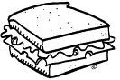

___S-sandwich__ ___T-taco_____ ___C-cap____ ___B-bat_____
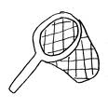


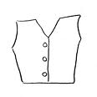
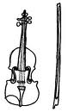

____M-mug____ ___V-vest_______ __H-house____ ___N-net____
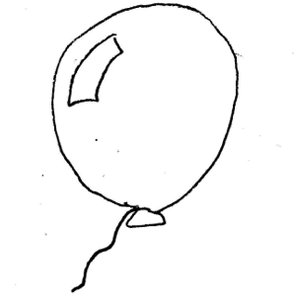
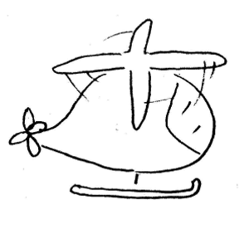
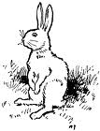

____V-violin____ ___R-rabbit____ __H-helicopter__ _B-balloon__
LET US WRITE THIS WAY
Direction: Practice writing the letters two times.
S
_________________________________________________________________________
s
_ _ _ _ _ _ _ _ _ _ _ _ _ _ _ _ _ _ _ _ _ _ _ _ _ _ _ _ _ _ _ _ _ _ _ _ _ _ _ _ _ _ _ _ _ _ _ _ _
_________________________________________________________________________
_________________________________________________________________________
m
M
_ _ _ _ _ _ _ _ _ _ _ _ _ _ _ _ _ _ _ _ _ _ _ _ _ _ _ _ _ _ _ _ _ _ _ _ _ _ _ _ _ _ _ _ _ _ _ _ _
_________________________________________________________________________
_________________________________________________________________________
v
V
_ _ _ _ _ _ _ _ _ _ _ _ _ _ _ _ _ _ _ _ _ _ _ _ _ _ _ _ _ _ _ _ _ _ _ _ _ _ _ _ _ _ _ _ _ _ _ _ _
_________________________________________________________________________
B
_________________________________________________________________________
b
_ _ _ _ _ _ _ _ _ _ _ _ _ _ _ _ _ _ _ _ _ _ _ _ _ _ _ _ _ _ _ _ _ _ _ _ _ _ _ _ _ _ _ _ _ _ _ _
_________________________________________________________________________
N
_________________________________________________________________________
n
_ _ _ _ _ _ _ _ _ _ _ _ _ _ _ _ _ _ _ _ _ _ _ _ _ _ _ _ _ _ _ _ _ _ _ _ _ _ _ _ _ _ _ _ _ _ _ _ _
_________________________________________________________________________

T
_________________________________________________________________________
_ _ _ _ _ _ _ _ _ _ _ _ _ _ _ _ _ _ _ _ _ _ _ _ _ _ _ _ _ _ _ _ _ _ _ _ _ _ _ _ _ _ _ _ _ _ _ _ _
_________________________________________________________________________
H
_________________________________________________________________________
h
_ _ _ _ _ _ _ _ _ _ _ _ _ _ _ _ _ _ _ _ _ _ _ _ _ _ _ _ _ _ _ _ _ _ _ _ _ _ _ _ _ _ _ _ _ _ _ _ _
_________________________________________________________________________

CLIMATE ACTIVITIES
Directions:
- Color the pictures. Then cut and paste the pictures to the correct season.

Winter

Summer

TELEVISION ACTIVITIES
Directions:
- Identify the different part of the story you are watching: setting, main characters, problem, and solution.
- Illustrate the setting and main characters on the sheet provided. Write a sentence on how a character in the show made you feel.
- Write a sentence about your favorite part.
- Illustrate and/or write about the problem and how it was solved in the show.

Setting | Main Characters
Answers may vary. | Answers may vary.
“ _______________ made me feel ________________ because

____________________________________________________.”

Problem | Solution(s)
Answers may vary. | Answers may vary.

My favorite part of the show is

______ Answers may vary.__________________________________________________

_________________________________________________________________________

_________________________________________________________________________

_________________________________________________________________________

________________________________________________________________________.

READING LOG
Name of Book | Author | Book Review  Did you like this book?

