Math 6
Winter Student
Enrichment Packet
ANSWER KEY

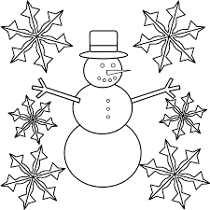
™
PRINCE GEORGE’S COUNTY PUBLIC SCHOOLS
Office of Academic Programs
Department of Curriculum and Instruction

Math 6 Winter Student Enrichment Packet
Answer Key

Activity 1
Student answers will vary. See activity directions and rubric.

Activity 2
Student number line should resemble the following image. Give special attention to the tick marks and plotting of the values.

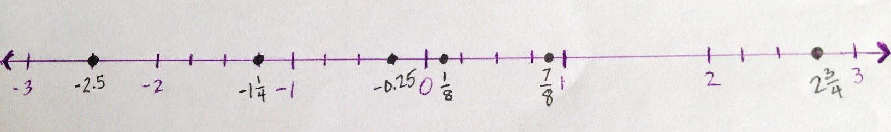

Activity 3
Student answers will vary. See activity directions and rubric.

Activity 4
Students’ answer should include a reasonable model to represent the application of the distributive property. For example, for 3(3x + 5):

3x + 5


3

This model shows that 3(3x + 5) is equivalent to 9x + 15 because 3 · 3x = 9x and 3 · 5 = 15.

Activity 5
Students should show, by applying one operation per line, that the value of the given expression is 33.5.
Students should show by placing parentheses in various positions, such as:

(7 + 7) ÷ 2 + 2³ ▪ 3 – 1 = 37
7 + 7 ÷ (2 + 2³) ▪ 3 – 1 = 8.1
7 + 7 ÷ 2 + 2³ ▪ (3 – 1) = 26.5
7 + 7 ÷ (2 + 2³ ▪ 3) – 1 = 6

Activity 6
Student answers will vary. See activity directions and rubric.

Activity 7
Student answers will vary. See activity directions and rubric.

Activity 8
Students should include 10 examples that follow the model given in the example of the activity directions.

Activity 9
Student answers will vary. See activity directions and rubric.

